National Textile University, Faisalabad

Department of Computer Science
Name | Dawood Saif
Class | SE-6th (A)
Reg. No. | 23-NTU-CS-1145
Course | Mobile Application Development
Submitted To | Sir Rehan Sarwar
Submission Date | 02/03/2026
Lab Plan | 1

Lab Plan 1: Basics and Introduction Of Flutter

Task 1:

Create a Flutter Project
Shortcut key → Ctrl+shift+p
Create a Stateless Widget (stle) and Add AppBar to your Project.
Change the color of the Appbar.
Align the Text on the Appbar at center.
Add you name at the center of the screen.

Code:
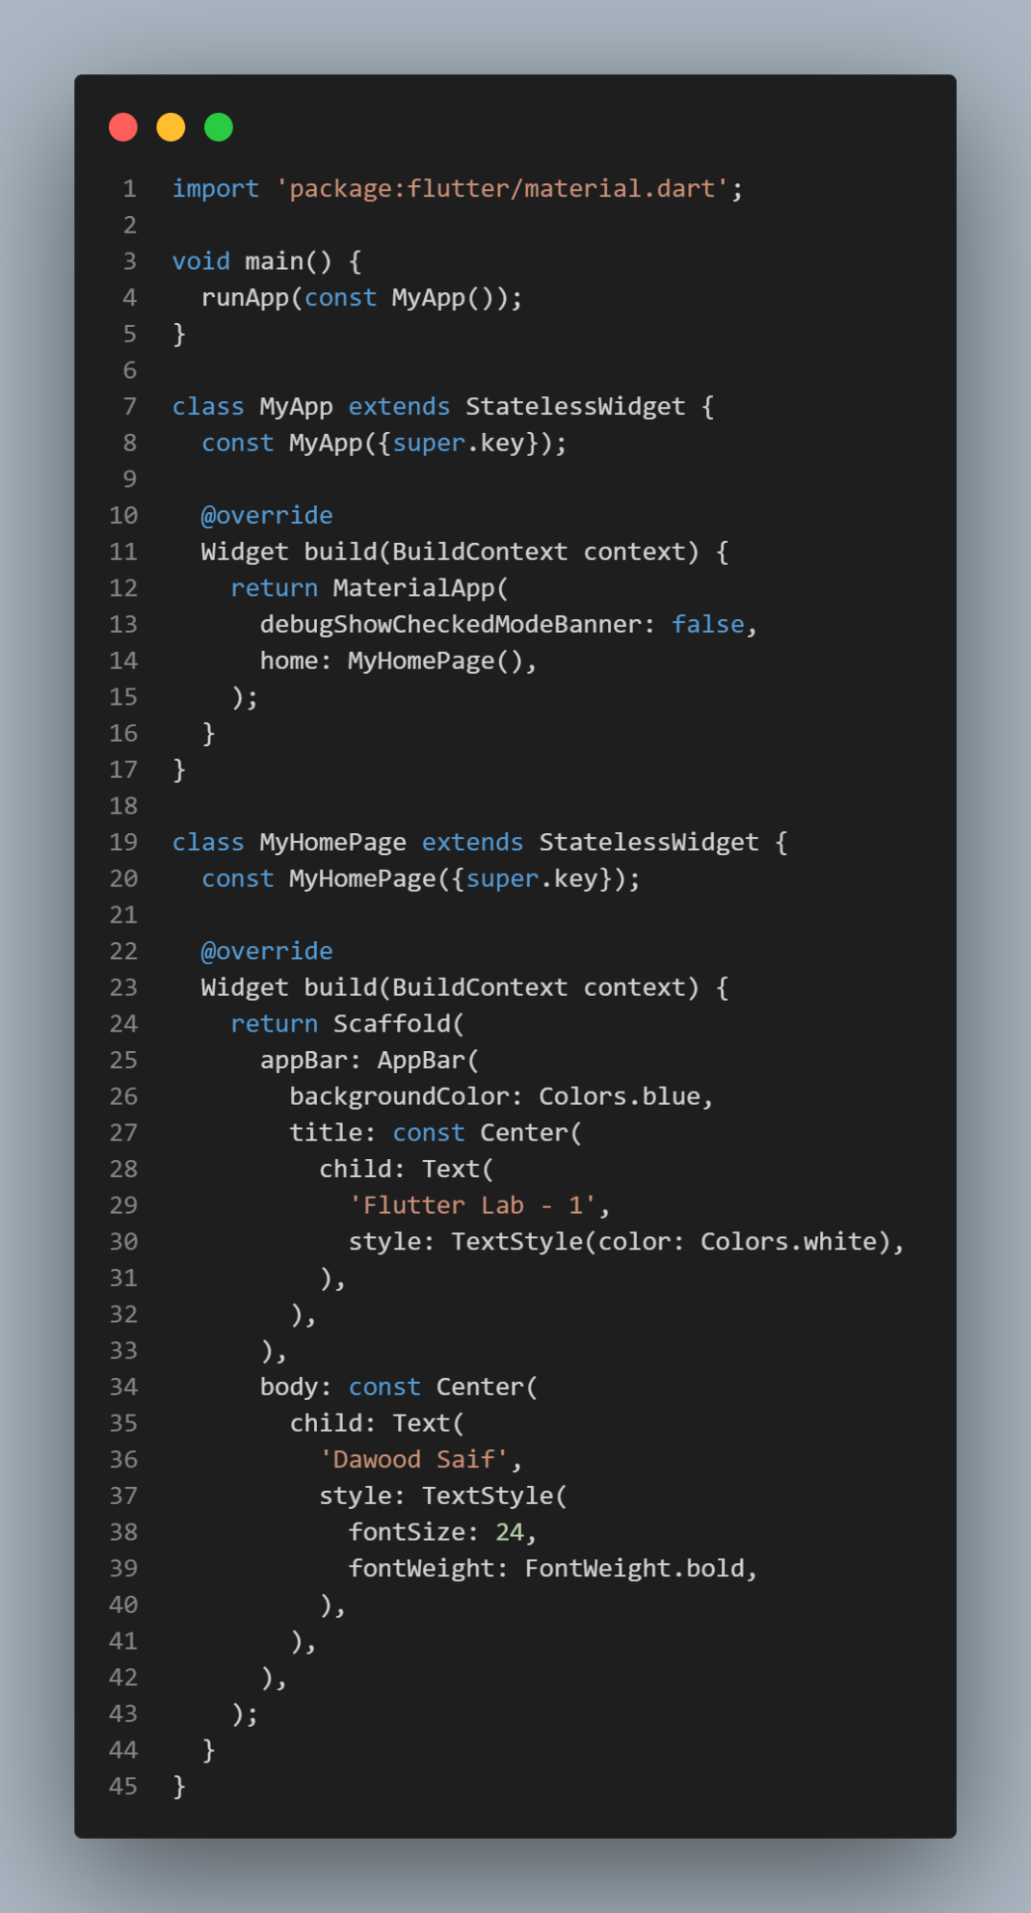

Output Screenshot:
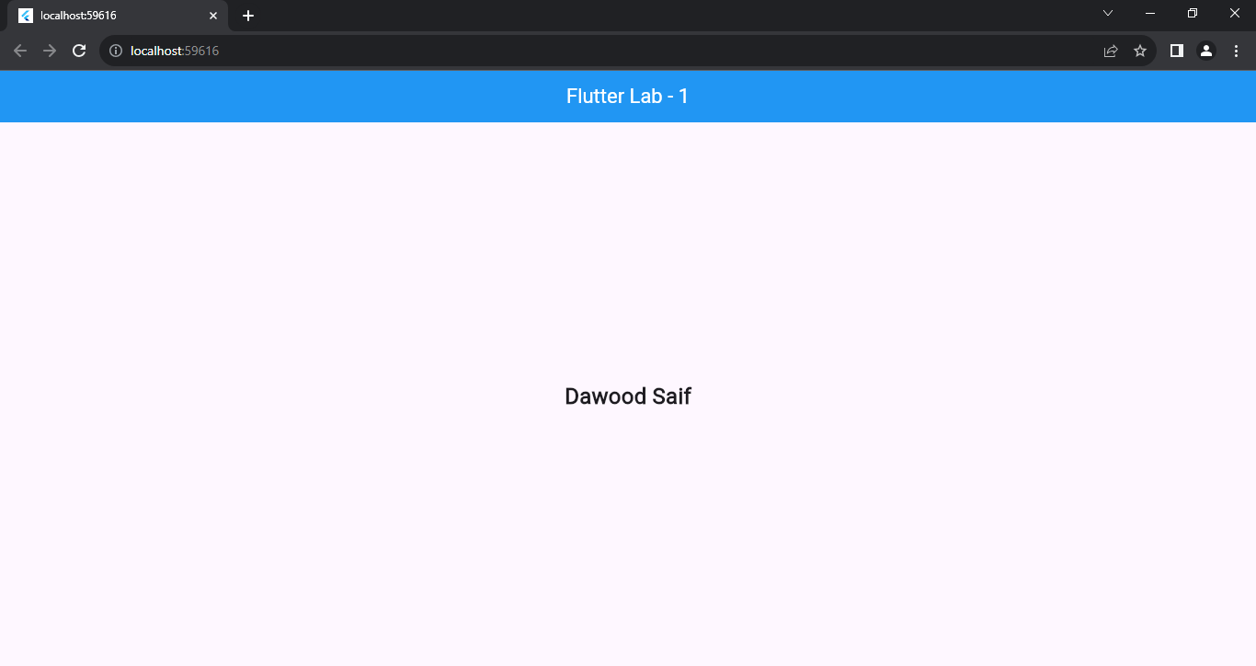

Task 2:

Design the UI Layout:
Inside the `Scaffold`, create a `Column` widget.
Add a `Row` widget as the first child of the `Column`.

Use Size box for spaces
Assets and Network Images
Download the image form google
Add assets to pubspec.yml file
Add image to your Project by using assets
Add Image to your project by using Network Image

Code:
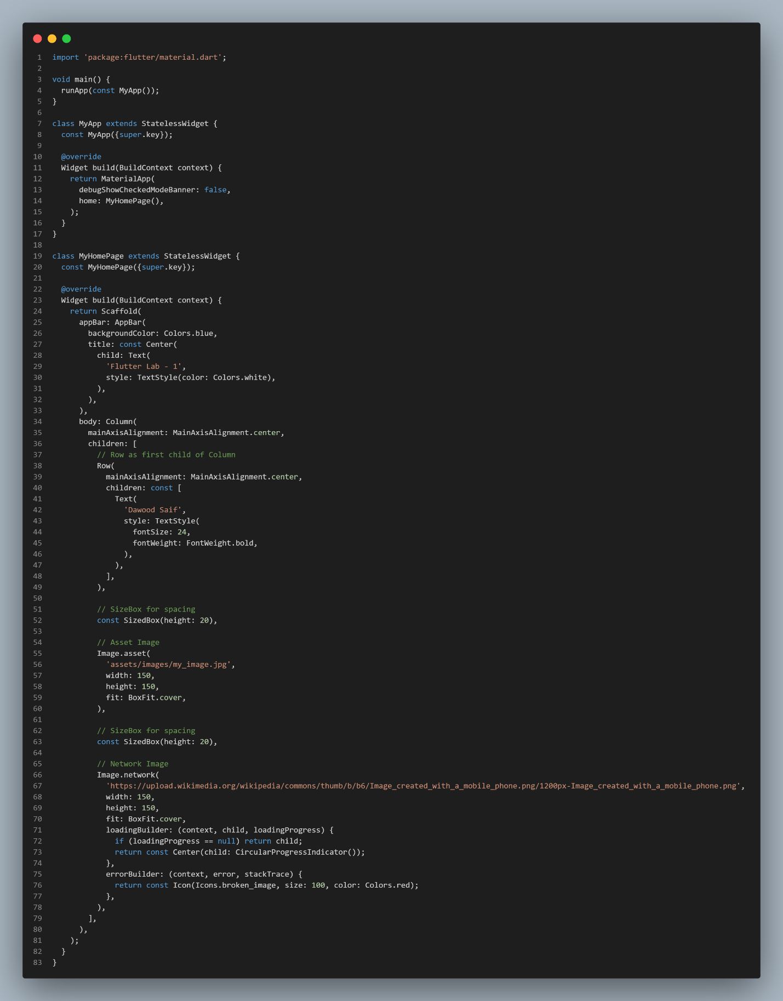

Output Screenshot:
